Final Project

2024-12-02

## 1(a)

$X_{\left(1\right)}≤Q_{p}≤X_{\left(n\right)}$ is satisfied if and only if at least one of the $X_{i}$ values is less than or equal to $Q_{p}$, and at least one of the $X_{i}$ values is greater than or equal to $Q_{p}$.

The complementary event is that all $n$ observations are either below $Q_{p}$ or above $Q_{p}$.

so that we can derive the probability of this event:

$$Pr\left[X_{\left(1\right)}≤Q_{p}≤X_{\left(n\right)}\right]=1-Pr\left[\text{all }X_{i}<Q_{p}\right]-Pr\left[\text{all }X_{i}>Q_{p}\right].$$

Since $X_{i}$ are i.i.d., we have:

$$Pr\left[\text{all }X_{i}<Q_{p}\right]=p^{n}, Pr\left[\text{all }X_{i}>Q_{p}\right]={\left(1-p\right)}^{n}.$$

Thus, we get:

$$Pr\left[X_{\left(1\right)}≤Q_{p}≤X_{\left(n\right)}\right]=1-p^{n}-{\left(1-p\right)}^{n}.$$

As a result, the minimal sample size n that satisfies the inequality depends only on p (and not on the unknown CDF F).

## 1(b-c)

# find the minimal n to satisfy the inequality  
find_min_n <- function(p, value1) {  
 n <- 1  
 while (TRUE) {  
 prob <- 1 - p^n - (1 - p)^n  
 if (prob >= value1) break  
 n <- n + 1  
 }  
 return(n)  
}  
  
# values for p  
p_values <- c(0.01, 0.025, 0.05, 0.10, 0.20, 0.40, 0.50)  
  
# let Pr=0.99  
n_99 <- sapply(p_values, function(p) find_min_n(p, 0.99))  
  
# let Pr=0.999  
n_999 <- sapply(p_values, function(p) find_min_n(p, 0.999))  
  
# Results  
results <- data.frame(p = p_values, n_99 = n_99, n_999=n_999)  
transposed_results <- t(results)  
print(transposed_results,row.names = FALSE)

## [,1] [,2] [,3] [,4] [,5] [,6] [,7]  
## p 0.01 0.025 0.05 0.1 0.2 0.4 0.5  
## n_99 459.00 182.000 90.00 44.0 21.0 10.0 8.0  
## n_999 688.00 273.000 135.00 66.0 31.0 14.0 11.0

## 2(a) Mean and Variance of Portfolio Return

With two random variables $X_{1}$ and $X_{2}$ as the daily log return values of stock prices, we can calculate the portfolio return as:

$$X\left(w\right)=wX_{1}+\left(1-w\right)X_{2}$$

### Mean of the Portfolio Return

So the expected value of $X\left(w\right)$ is:

$$μ\left(w\right)=E\left[X\left(w\right)\right]=wE\left[X_{1}\right]+\left(1-w\right)E\left[X_{2}\right]=wμ_{1}+\left(1-w\right)μ_{2}=μ_{2}+\left(μ_{1}-μ_{2}\right)w$$

As a result, we have:

$$μ\left(w\right)=c_{0}+c_{1}w$$

where $c_{0}=μ_{2}$ and $c_{1}=μ_{1}-μ_{2}$.

### Variance of the Portfolio Return

The variance of the portfolio $X\left(w\right)$ is given by:

$$σ^{2}\left(w\right)=\text{Var}\left[X\left(w\right)\right]=w^{2}σ_{1}^{2}+{\left(1-w\right)}^{2}σ_{2}^{2}+2w\left(1-w\right)ρσ_{1}σ_{2}$$

We can expand it as:

$$σ^{2}\left(w\right)=\left(σ_{1}^{2}+σ_{2}^{2}-2ρσ_{1}σ_{2}\right)w^{2}-2\left(σ_{2}^{2}-ρσ_{1}σ_{2}\right)w+σ_{2}^{2}$$

Let:

$a=σ_{1}^{2}+σ_{2}^{2}-2ρσ_{1}σ_{2}$

$b=σ_{2}^{2}-ρσ_{1}σ_{2}$

$c=σ_{2}^{2}$

As a result, we can express the variance of the portfolio as:

$$σ^{2}\left(w\right)=aw^{2}-2bw+c$$

### Justification for $a≥0$

Because $ρ∈\left(-1,1\right)$,

$$a=σ_{1}^{2}+σ_{2}^{2}-2ρσ_{1}σ_{2}≥2σ_{1}σ_{2}-2ρσ_{1}σ_{2}=\left(2-2ρ\right)σ_{1}σ_{2}≥0$$

## 2(b) Minimizing the Portfolio Variance

To minimize the variance $σ^{2}\left(w\right)$, we differentiate with respect to $w$:

$$\frac{d}{dw}σ^{2}\left(w\right)=2aw-2b$$

Setting the derivative equal to 0:

$$2aw-2b=0$$

$$w=\frac{b}{a}$$

Thus, the optimal weight $\hat{w}$ that minimizes variance is:

$$\hat{w}=\frac{b}{a}$$

### Case Analysis

if $\frac{b}{a}<0$, $b=σ_{2}^{2}-ρσ_{1}σ_{2}<0$, then $ρ>\frac{σ_{2}}{σ_{1}}$, the variance is minimized when $\hat{w}=0$;

if $\frac{b}{a}>1$, then $ρ>\frac{σ_{1}}{σ_{2}}$, the variance is minimized when $\hat{w}=1$;

otherwise, $\frac{b}{a}$ falls between 0 and 1, so when $\hat{w}=\frac{b}{a}$, the variance is minimized.

## 2(c)

The sharpe ratio is $\frac{μ\left(ω\right)}{σ\left(ω\right)}$.

$$SR\left(ω\right)=\frac{c_{0}+c_{1}ω}{\sqrt{aω^{2}-2bω+c}}$$ When $\frac{d\left(SR\left(ω\right)\right)}{dω}=0$ and $\frac{d^{2}SR\left(ω\right)}{dω^{2}}≤0\text{, }ω$ is the optimal value that maximize the sharpe ratio.

# if (!require(Deriv)) {install.packages("Deriv")}   
library(Deriv)  
f <- function(omega, a, b, c, c0, c1) {  
 (c0 + c1 * omega) / sqrt(a * omega^2 - 2 * b * omega + c)  
}  
  
# find derivatives  
f_first <- Deriv(f, "omega", combine = TRUE)  
f_second <- Deriv(f_first, "omega", combine = TRUE)  
  
# extract intermediate variable expression  
extract_variables <- function(expr) {  
 expr_text <- deparse(expr)   
 vars <- gregexpr("\\.e[0-9]+ <- .*", expr_text)   
 matches <- regmatches(expr_text, vars)   
 unlist(matches)   
}  
  
# output intermediate variables  
cat("first order derivative intermediate variables:\n")

## first order derivative intermediate variables:

cat(paste(extract_variables(body(f_first)), collapse = "\n"), "\n\n")

## .e1 <- 2 * b  
## .e2 <- a * omega  
## .e4 <- c + omega * (.e2 - .e1)

cat("second order derivative intermediate variables:\n")

## second order derivative intermediate variables:

cat(paste(extract_variables(body(f_second)), collapse = "\n"), "\n\n")

## .e1 <- 2 * b  
## .e2 <- a * omega  
## .e4 <- 2 * .e2 - .e1  
## .e6 <- c + omega * (.e2 - .e1)  
## .e7 <- c0 + c1 * omega  
## .e9 <- .e4 * .e7/.e6

# output first and second order derivatives  
cat("f'(x) =", deparse(body(f_first)), "\n")

## f'(x) = { .e1 <- 2 * b .e2 <- a * omega .e4 <- c + omega * (.e2 - .e1) (c1 - 0.5 * ((2 * .e2 - .e1) * (c0 + c1 * omega)/.e4))/sqrt(.e4) }

cat("f''(x) =", deparse(body(f_second)), "\n")

## f''(x) = { .e1 <- 2 * b .e2 <- a * omega .e4 <- 2 * .e2 - .e1 .e6 <- c + omega * (.e2 - .e1) .e7 <- c0 + c1 * omega .e9 <- .e4 * .e7/.e6 -((0.5 * (.e4 * (c1 - .e9) + 2 * (a * .e7)) + 0.5 * (.e4 * (c1 - 0.5 * .e9)))/(.e6 * sqrt(.e6))) }

With these formulas, we can see that the second order derivatives always negative, so When $∃ω∈\left[0,1\right],\frac{d\left(SR\left(ω\right)\right)}{dω}=0$, we can get the $ω$ maximize the sharpe ratio directly by solving $\frac{d\left(SR\left(ω\right)\right)}{dω}=0$. If the the global optimal $ω∉\left[0,1\right]$, if $\frac{d\left(SR\left(ω\right)\right)}{dω}{\left|​_{ω=1}<0,\frac{d\left(SR\left(ω\right)\right)}{dω}\right|}_{ω=0}<0$, then optimal $ω∈\left[0,1\right]$ is 0; else if $\frac{d\left(SR\left(ω\right)\right)}{dω}{\left|​_{ω=1}>0,\frac{d\left(SR\left(ω\right)\right)}{dω}\right|}_{ω=0}>0$, then optimal $ω∈\left[0,1\right]$ is 1.

# Numerical Simulation  
mu1 <- 0.056   
mu2 <- 0.04   
sigma1 <- 0.1   
sigma2 <- 0.08   
rho <- 0.2 # correlation coefficient of 1 and 2  
  
# calculate parameters  
c0 <- mu2  
c1 <- mu1 - mu2  
a <- sigma1^2 + sigma2^2 - 2 * rho * sigma1 * sigma2  
b <- sigma2^2 - rho * sigma1 * sigma2  
c <- sigma2^2  
  
# Sharpe Ratio function  
SR <- function(w) {  
 mu_w <- c0 + c1 * w  
 sigma_w <- sqrt(a * w^2 - 2 * b * w + c)  
 return(mu_w / sigma_w)  
}  
  
# generate weight array and Sharpe Ratio array  
w_values <- seq(0, 1, length.out = 500)  
sr_values <- sapply(w_values, SR)  
  
# plot Sharpe Ratio v.s. w  
plot(w_values, sr_values, type = "l", lwd = 2, col = "blue",  
 main = "Sharpe Ratio SR(w) vs Portfolio Weight w",  
 xlab = "Portfolio Weight w", ylab = "Sharpe Ratio SR(w)")  
abline(h = 0, col = "black", lty = 2)  
grid()

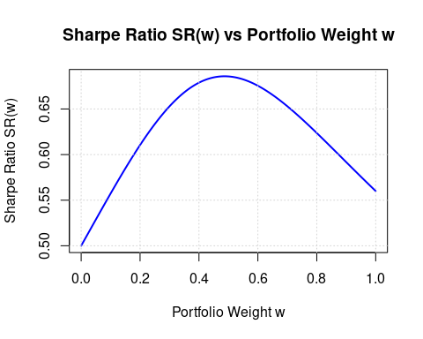

## 3

### 3.a

if (!requireNamespace("quantmod", quietly = TRUE)) install.package("quantmod")

## Registered S3 method overwritten by 'quantmod':  
## method from  
## as.zoo.data.frame zoo

library(quantmod)

## Loading required package: xts

## Loading required package: zoo

##   
## Attaching package: 'zoo'

## The following objects are masked from 'package:base':  
##   
## as.Date, as.Date.numeric

## Loading required package: TTR

# download data  
getSymbols(c("AAPL", "MSFT"), from = "2023-11-01", to = "2024-10-31")

## [1] "AAPL" "MSFT"

# calculate daily return  
AAPL.returns <- as.numeric(dailyReturn(AAPL)) * 100  
MSFT.returns <- as.numeric(dailyReturn(MSFT)) * 100  
  
# estimate moment  
mu1 <- mean(AAPL.returns)  
mu2 <- mean(MSFT.returns)  
sigma1 <- sd(AAPL.returns)  
sigma2 <- sd(MSFT.returns)  
rho <- cor(AAPL.returns, MSFT.returns)  
  
# print moment estimates  
cat(sprintf("µ1 = %.4f, µ2 = %.4f, σ1 = %.4f, σ2 = %.4f, ρ = %.4f\n", mu1, mu2, sigma1, sigma2, rho))

## µ1 = 0.1284, µ2 = 0.1031, σ1 = 1.4227, σ2 = 1.1781, ρ = 0.4745

# calculate parameter coefficient in 2(a)  
c0 <- mu2  
c1 <- mu1 - mu2  
a <- sigma1^2 + sigma2^2 - 2 * rho * sigma1 * sigma2  
b <- sigma2^2 - rho * sigma1 * sigma2  
c <- sigma2^2  
  
# print parameter coefficient in 2(a)  
cat(sprintf("c0 = %.4f, c1 = %.4f, a = %.4f, b = %.4f, c = %.4f\n", c0, c1, a, b, c))

## c0 = 0.1031, c1 = 0.0252, a = 1.8215, b = 0.5928, c = 1.3880

### 3.b

sigma2 <- function(w) {  
 a * w^2 - 2 * b * w + c  
}  
  
# generate weight w array and sigma array  
w_values <- seq(0, 1, length.out = 1000)  
sigma2_values <- sapply(w_values, sigma2)  
  
# plot sigma v.s. w  
plot(w_values, sigma2_values, type = "l", col = "blue", lwd = 2,  
 main = expression(sigma^2~vs~w),  
 xlab = "w", ylab = expression(sigma^2))

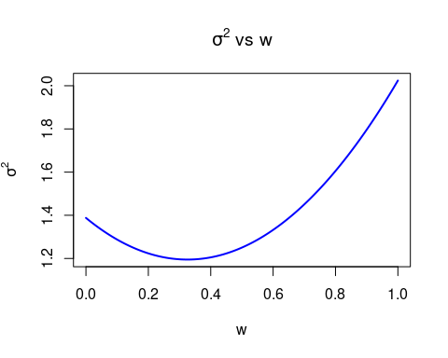

# find minimum sigma  
opt_w <- optimize(sigma2, interval = c(0, 1))$minimum  
min_sigma2 <- sigma2(opt_w)  
mu_opt <- c0 + c1 * opt_w  
sigma_opt <- sqrt(min_sigma2)  
  
# output w minimizing sigma  
cat(sprintf("Optimal w = %.2f, µ(w^) = %.4f, σ(w^) = %.4f\n", opt_w, mu_opt, sigma_opt))

## Optimal w = 0.33, µ(w^) = 0.1113, σ(w^) = 1.0932

### 3.c

# calculate sharpe ratio function  
sharpe_ratio <- function(w) {  
 mu_w <- c0 + c1 * w  
 sigma_w <- sqrt(a * w^2 - 2 * b * w + c)  
 mu_w / sigma_w  
}  
  
# calculate Sharpe Ratio  
sr_values <- sapply(w_values, sharpe_ratio)  
  
# plot w v.s. sharpe ratio  
plot(w_values, sr_values, type = "l", col = "blue", lwd = 2,  
 main = "Sharpe Ratio SR(w) vs w",  
 xlab = "w", ylab = "Sharpe Ratio SR(w)")

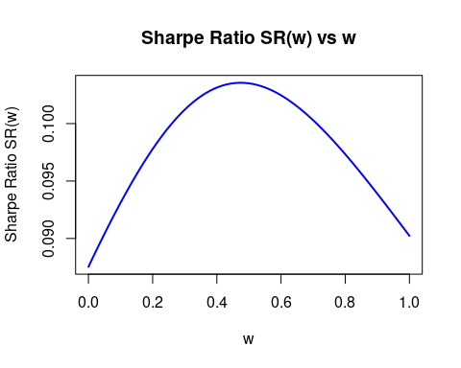

# optimize w to maximize Sharpe ratio  
opt_sr <- optimize(sharpe_ratio, interval = c(0, 1), maximum = TRUE)  
opt_w_sr <- opt_sr$maximum  
max_sr <- opt_sr$objective  
mu_opt_sr <- c0 + c1 * opt_w_sr  
sigma_opt_sr <- sqrt(sigma2(opt_w_sr))  
  
# print optimal w and sharpe ratio  
cat(sprintf("Optimal w for Sharpe Ratio = %.2f, µ(w^) = %.4f, σ(w^) = %.4f, SR(w^) = %.4f\n",  
 opt_w_sr, mu_opt_sr, sigma_opt_sr, max_sr))

## Optimal w for Sharpe Ratio = 0.47, µ(w^) = 0.1151, σ(w^) = 1.1115, SR(w^) = 0.1035

### 3.d

# Using Historical return data  
# calculate VaR function   
VaR <- function(returns, alpha) {  
 quantile(-returns, probs = alpha)  
}  
  
# calculating VaR  
alphas <- c(0.95, 0.975, 0.99)  
VaR_AAPL <- sapply(alphas, VaR, returns = AAPL.returns)  
VaR_MSFT <- sapply(alphas, VaR, returns = MSFT.returns)  
  
# print VaR  
VaR_table <- data.frame(  
 Alpha = alphas,  
 VaR_AAPL = round(VaR_AAPL, 4),  
 VaR_MSFT = round(VaR_MSFT, 4)  
)  
print(VaR_table)

## Alpha VaR_AAPL VaR_MSFT  
## 95% 0.950 2.1743 2.0681  
## 97.5% 0.975 2.7633 2.4703  
## 99% 0.990 3.2464 3.2388

# Using Normal Distribution(Can be change to any other customized distribution) return  
# VaR based on Normal Distribution Return  
compute_var_normal <- function(mu, sigma, alpha) {  
 VaR <- -(mu - sigma * qnorm(alpha))  
 return(VaR)  
}  
  
# Return Distribution Parameter Estimation  
mu_AAPL <- mean(AAPL.returns, na.rm = TRUE)  
sigma_AAPL <- sd(AAPL.returns, na.rm = TRUE)  
mu_MSFT <- mean(MSFT.returns, na.rm = TRUE)  
sigma_MSFT <- sd(MSFT.returns, na.rm = TRUE)  
  
# Single Stock VaR  
VaR_AAPL_normal <- sapply(alphas, compute_var_normal, mu = mu_AAPL, sigma = sigma_AAPL)  
VaR_MSFT_normal <- sapply(alphas, compute_var_normal, mu = mu_MSFT, sigma = sigma_MSFT)  
  
# Print VaRs  
VaR_table <- data.frame(  
 Alpha = alphas,  
 VaR_AAPL = round(VaR_AAPL_normal, 4),  
 VaR_MSFT = round(VaR_MSFT_normal, 4)  
)  
print(VaR_table)

## Alpha VaR_AAPL VaR_MSFT  
## 1 0.950 2.2117 1.8347  
## 2 0.975 2.6600 2.2059  
## 3 0.990 3.1812 2.6376

### 3.e

# Using Historical Return Data  
# function to calculate Portfolio VaR  
VaR_portfolio <- function(w, alpha) {  
 portfolio_returns <- w * AAPL.returns + (1 - w) * MSFT.returns  
 VaR(portfolio_returns, alpha)  
}  
  
# calculating w and VaR(w)  
for (alpha in alphas) {  
 VaR_values <- sapply(w_values, VaR_portfolio, alpha = alpha)  
 plot(w_values, VaR_values, type = "l", lwd = 2,  
 main = bquote(VaR[.(alpha)](w)~vs~w),  
 xlab = "w", ylab = bquote(VaR[.(alpha)](w)))  
   
 # optimize w to minimize VaR  
 opt_VaR <- optimize(VaR_portfolio, interval = c(0, 1), alpha = alpha)  
 opt_w_VaR <- opt_VaR$minimum  
 mu_opt_VaR <- c0 + c1 * opt_w_VaR  
 sigma_opt_VaR <- sqrt(sigma2(opt_w_VaR))  
   
 cat(sprintf("Optimal w for VaR (alpha=%.3f): w = %.2f, µ(w^) = %.4f, σ(w^) = %.4f\n",  
 alpha, opt_w_VaR, mu_opt_VaR, sigma_opt_VaR))  
}

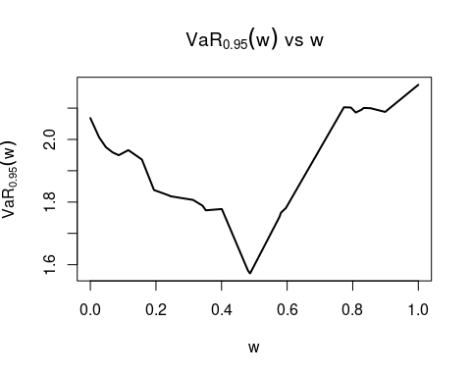

## Optimal w for VaR (alpha=0.950): w = 0.49, µ(w^) = 0.1154, σ(w^) = 1.1147

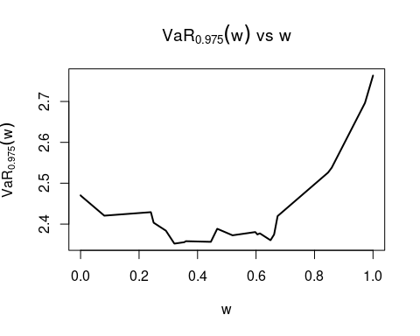

## Optimal w for VaR (alpha=0.975): w = 0.32, µ(w^) = 0.1112, σ(w^) = 1.0932

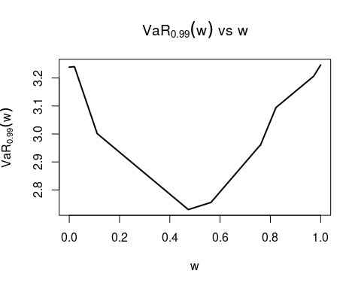

## Optimal w for VaR (alpha=0.990): w = 0.47, µ(w^) = 0.1151, σ(w^) = 1.1114

When using Normal distribution as return distribution, all optimal $$ to minimize the VaRs are the same, and they are the same as the $ω$ to minimize $σ$ of the portfolio.

# Using Normal Distribution Return  
# Compute Portfolio VaR  
VaR_portfolio_normal <- function(mu1, mu2, sigma1, sigma2, rho, alpha, w) {  
 mu_portfolio <- w * mu1 + (1 - w) * mu2  
 sigma_portfolio <- sqrt((w^2) * sigma1^2 + ((1 - w)^2) * sigma2^2 + 2 * w * (1 - w) * rho * sigma1 * sigma2)  
 compute_var_normal(mu_portfolio, sigma_portfolio, alpha)  
}  
  
# calculating w and VaR(w)  
for (alpha in alphas) {  
 VaR_values <- sapply(w_values, VaR_portfolio_normal, mu1 = mu_AAPL, mu2 = mu_MSFT, sigma1 = sigma_AAPL, sigma2 = sigma_MSFT, rho = rho, alpha = alpha)  
 plot(w_values, VaR_values, type = "l", lwd = 2,  
 main = bquote(VaR[.(alpha)](w)~vs~w),  
 xlab = "w", ylab = bquote(VaR[.(alpha)](w)))  
   
 # optimize w to minimize VaR  
 opt_VaR <- optimize(VaR_portfolio, interval = c(0, 1), alpha = alpha)  
 opt_w_VaR <- opt_VaR$minimum  
 mu_opt_VaR <- c0 + c1 * opt_w_VaR  
 sigma_opt_VaR <- sqrt(sigma2(opt_w_VaR))  
   
 cat(sprintf("Optimal w for VaR (alpha=%.3f): w = %.2f, µ(w^) = %.4f, σ(w^) = %.4f\n",  
 alpha, opt_w_VaR, mu_opt_VaR, sigma_opt_VaR))  
}

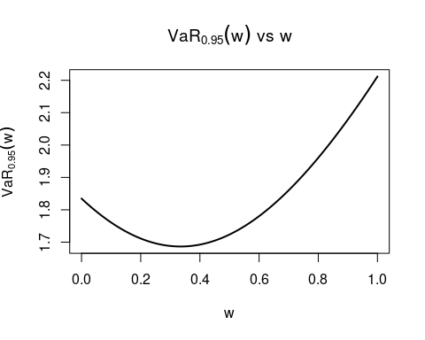

## Optimal w for VaR (alpha=0.950): w = 0.49, µ(w^) = 0.1154, σ(w^) = 1.1147

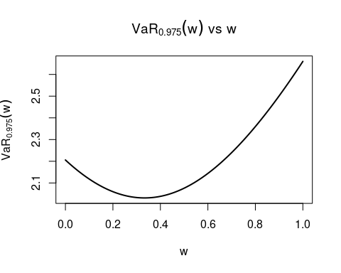

## Optimal w for VaR (alpha=0.975): w = 0.32, µ(w^) = 0.1112, σ(w^) = 1.0932

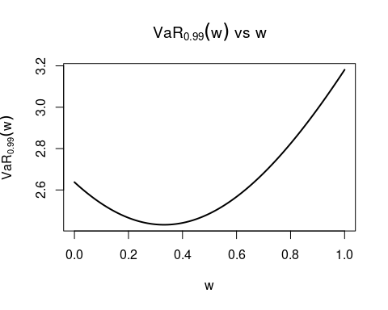

## Optimal w for VaR (alpha=0.990): w = 0.47, µ(w^) = 0.1151, σ(w^) = 1.1114